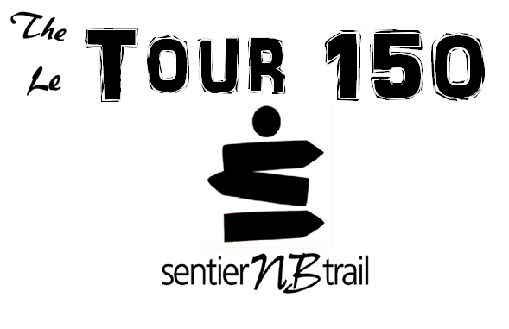
Charlotte Hill
New Brunswick Trails Council For immediate release
(506)454-1110
marketing@sentiernbtrail.com
New Brunswick Goes On Tour
Province comes together on 1300 kilometers of trail
The New Brunswick Trail Council Inc. (NBTICI) announces “The Tour 150”. This relay-style event will bring together participants from all four corners of the province using the trail networks. A wooden map of New Brunswick will be divided into four pieces and each piece will be brought to a different starting point at the outer edge of the province. Starting August 10th each piece will move from its starting point, along New Brunswick’s trail networks, and will be joined together at a public event at Government House in Fredericton on August 26th at 1:00pm. The pieces will be carried by horseback, kayak, canoe, bike, wheel chair, and foot over more than 1300 kilometers of trail.
“This will be a historic event.” says Executive Director of New Brunswick Trails Council, Poul Jorgensen. “We will be celebrating both the connection of the Trans Canada Trail through our province, which has been over 20 years in the making, and Canada’s 150th year of confederation.”
New Brunswick’s portion of the Trans Canada Trail will be traversed in both directions with participants starting in Edmundston and Cape Jourimain to meet in Fredericton. Other trail networks will be followed from Lameque Island, on the Acadian peninsula, and St. Stephen, in the south-west, to join up with the groups making their way inland. The relay will involve participants from 17 organizations and trail supporters around the province who will complete the course over two weeks. There will be a finish line celebration at Government House in Fredericton on August 26th, where the four pieces of the province will be assembled and presented to Lt-Gov Jocelyne Roy Vienneau for public display at Government House. For a listing of locations and dates when the relay will be passing through an area please see the New Brunswick Trails Council website. www.sentiernbtrail.com
NBTCI: is a membership/volunteer organization dedicated to the advancement of the non-motorized trails movement in New Brunswick. Its mandate is to work for the betterment of trails throughout New Brunswick and to help Local Trail Sponsors (LTS) build, maintain, and promote their local trails. Local Trail Sponsors are the local branches of the NBTCI. They are community-based trails groups made up of volunteers who build, maintain and promote local sections of trail. The organization manages, maintains and promotes over 2000 km of non-motorized trails throughout the province of New Brunswick with 5 core uses: walking, biking, horseback riding, cross country skiing and snowmobiling (where permitted).

